The problem found is related to the RS485 circuit to understand the trouble a brief recap is necessary:

1. The RS485 driver require to work properly a polarization circuit, typically two resistors connected one to VCC and one to the GND (Fig.1 and see also <https://cwiki.carel.com/index.php/RS-485> ).
2. A BMS port and a FIELDBUS port have different polarization values, this due to the fact that a FIELDBUS is typically client, otherwise a BMS is a server.  
   A FIELDBUS port have a low value polarization resistor compared to BMS port.  
   Sometimes, typically in the pCO/cpCO family CAREL accept that a FIELDBUS port is used as a BMS port.
3. During the time most of the controller due to technical evolution have moved from VCC=5V (Fig.1) to 3V3. So that, some devices have a polarization resistor connected to 5V and some to 3V3.
4. Today there aren’t rules that prevent that a device powered at 5V could be connected to a device powered at 3V3.

What happen when a RS485 polarized at 5V is connected to an RS485 that is polarized at 3V3 ?   
Most of the time nothing.  
Suppose now that a device at 3V3 is powered off and the device at 5V is on.  
A current drain from the 5V to the 3V3 line (VCC) of the device, we have found that this current is enough to maintain on the 3V3 device or better in a state where the brownout was triggered but at the same time the reset circuit was not able to reach the right level to reset the uP.  
This put the 3V3 device is a state that after an apparently valid power off > power on sequence the device is stuck in a blocked state.

The simple way to avoid this problem is to put a diode (orange) in series to the polarization resistor connected to VCC that block the current when the device is powered off.

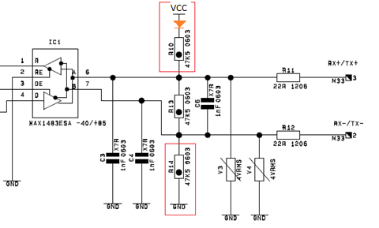Fig.1